1. Run the **MergePacks.exe** from D:\FTP\MergePacks tool\

2. Click on Build Report

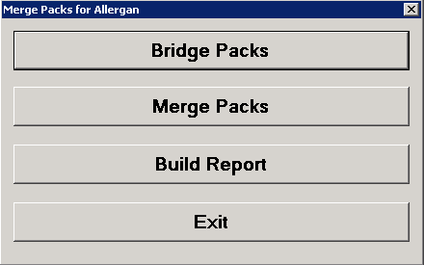

3. Select Country = DE and Previous Build = Previous Month. Click OK

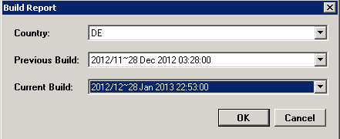

4. After successful run Below window will appear and the History Correction Report will generate at D:\FTP\MergePacks tool\Reports

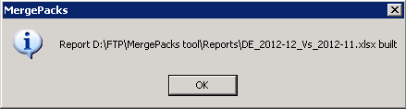

5. Copy the report file and backup at D:\FTP\MergePacks tool\Reports\YYYY\YYYYMM

where MM = Current Production Month Number (01, 02, ... 11,12)

and YYYY = Current Production Year.

16. Download the history excel file into Local and rename

History_Corrections_Germany_monYYYY.xlsx

where mon = Current Production Month Name

and YYYY = Current Production Year.

This file should mail to Allergan with delivery mail.

**Input CUBE vs Output Data:**

1. Downloadthe output file **Finland_S1_MMYYYY.csv** and input file in local pc.
2. Load cube in local pc **Analysis server** as below

* Open **sql server management studio** then click connect.

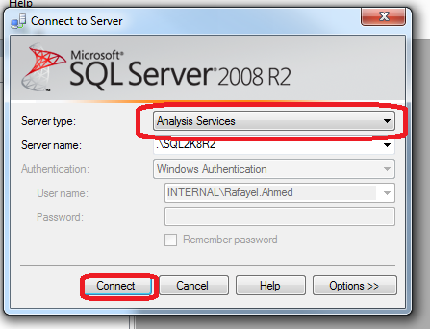

* create new data base as **Allergan_Finland_MMYYYY**

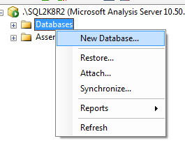

* restore database: click on restore

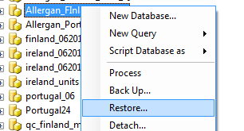

-Select the abf file then select database ..tick the db overwrite then click ok.

-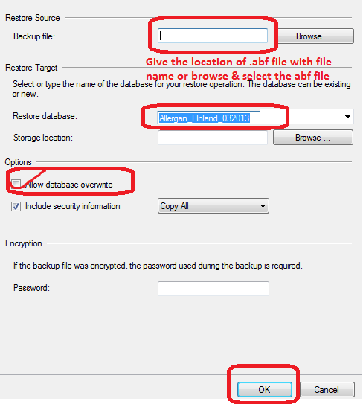

-database will restore.

**3. QC**

Open the output csv file **Finland_S1_MMYYYY.csv** with Textpad. Select 3 records for 3 measure Counting Units, Units and Values for a particular Product and SKU which have >0 values in latest month

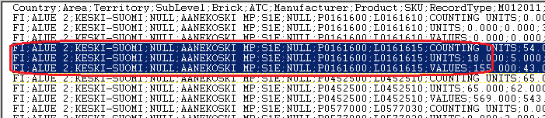

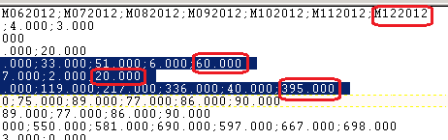

1. click browse

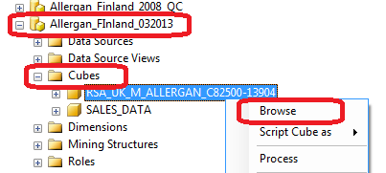

4.match the result with output csv

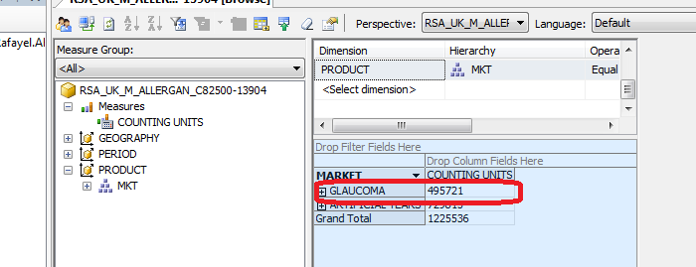

5.process in done.